Coding Challenge. 4

Maryam Saeed Noor Fatima

2025-02-25

# Coding Challenge 3

## **Q.No.3 (a)**

## **Q.No.6 (b)**

### Readme file link

[link to my Readme file](Coding%20challenge.4.md)

### Clickable Link to the ManuscDript

[Manuscript Link](i.%20Noel,%20Z.A.,%20Roze,%20L.V.,%20Breunig,%20M.,%20Trail,%20F.%202022.%20Endophytic%20fungi%20as%20promising%20biocontrol%20agent%20to%20protect%20wheat%20from%20Fusarium%20graminearum%20head%20blight.%20Plant%20Disease.%20https://doi.org/10.1094/PDIS-06-21-1253-RE)

## **Q.No.6 (b)**

## File Tree of Github

fs::dir_tree()

## .  
## ├── Coding challenge.4.Rmd  
## ├── Coding Challenge.4.Rproj  
## ├── Coding-challenge.4.docx  
## ├── Coding-challenge.4.html  
## ├── Coding-challenge.4.md  
## ├── Coding-challenge.4.pdf  
## ├── Coding-challenge.4.Rmd  
## ├── Coding-challenge.4_files  
## │ └── figure-gfm  
## │ ├── pressure-1.png  
## │ ├── unnamed-chunk-10-1.png  
## │ ├── unnamed-chunk-11-1.png  
## │ ├── unnamed-chunk-13-1.png  
## │ ├── unnamed-chunk-3-1.png  
## │ ├── unnamed-chunk-4-1.png  
## │ ├── unnamed-chunk-5-1.png  
## │ ├── unnamed-chunk-6-1.png  
## │ ├── unnamed-chunk-7-1.png  
## │ ├── unnamed-chunk-8-1.png  
## │ └── unnamed-chunk-9-1.png  
## └── MycotoxinData.csv

### Libraries

library(readr)  
library(ggplot2)  
library(tidyverse)

## ── Attaching core tidyverse packages ──────────────────────── tidyverse 2.0.0 ──  
## ✔ dplyr 1.1.4 ✔ stringr 1.5.1  
## ✔ forcats 1.0.0 ✔ tibble 3.2.1  
## ✔ lubridate 1.9.4 ✔ tidyr 1.3.1  
## ✔ purrr 1.0.2   
## ── Conflicts ────────────────────────────────────────── tidyverse_conflicts() ──  
## ✖ dplyr::filter() masks stats::filter()  
## ✖ dplyr::lag() masks stats::lag()  
## ℹ Use the conflicted package (<http://conflicted.r-lib.org/>) to force all conflicts to become errors

library(ggpubr)  
library(ggrepel)   
cbbPalette <- c("#000000", "#E69F00", "#56B4E9", "#009E73",  
 "#F0E442", "#0072B2", "#D55E00", "#CC79A7")

## **Q.No.3 (b)**

### Importing the excel file

Mycotoxin_Data <- read.csv("MycotoxinData.csv",na = "na")

## **Q.No.3 (c)**

### Creating a ggplot box plot

ggplot(Mycotoxin_Data, aes(x = Treatment, y = DON, fill = Cultivar)) +  
 geom_boxplot(outliers = F) +   
 xlab("") +   
 ylab("DON (ppm)") +   
 geom_point(alpha = 0.6, pch = 21, color = "black", position = position_jitterdodge()) +  
 scale_color_manual(values = c(cbbPalette[3], cbbPalette[4])) +  
 scale_fill_manual(values = c(cbbPalette[3], cbbPalette[4])) +  
 theme_classic() +  
 facet_wrap(~Cultivar)

## Warning: Removed 8 rows containing non-finite outside the scale range  
## (`stat_boxplot()`).

## Warning: Removed 8 rows containing missing values or values outside the scale range  
## (`geom_point()`).

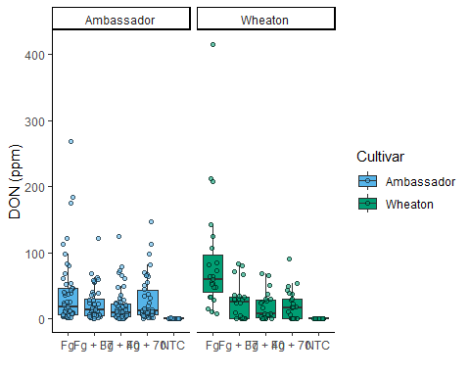

### Changing the factor levels

Mycotoxin_Data$Treatment <- factor(Mycotoxin_Data$Treatment, levels = c("NTC", "Fg", "Fg + 37", "Fg + 40", "Fg + 70"))

### a. Using DON as Y variable

DON.Plot <- ggplot(Mycotoxin_Data, aes(x = Treatment, y = DON, fill = Cultivar)) +  
 geom_boxplot(outliers = F) +   
 xlab("") +   
 ylab("DON (ppm)") +   
 geom_point(alpha = 0.6, pch = 21, color = "black", position = position_jitterdodge()) +  
 scale_color_manual(values = c(cbbPalette[3], cbbPalette[4])) +  
 scale_fill_manual(values = c(cbbPalette[3], cbbPalette[4])) +  
 theme_classic() +  
 facet_wrap(~Cultivar)  
DON.Plot

## Warning: Removed 8 rows containing non-finite outside the scale range  
## (`stat_boxplot()`).

## Warning: Removed 8 rows containing missing values or values outside the scale range  
## (`geom_point()`).

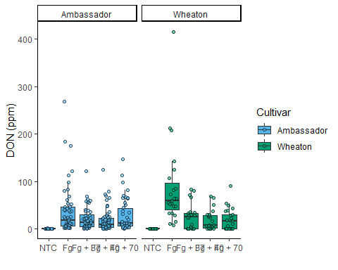

### a. Using X15DON as Y variable

X15ADON.Plot <- ggplot(Mycotoxin_Data, aes(x = Treatment, y = X15ADON, fill = Cultivar)) +  
 geom_boxplot(outliers = F) +   
 xlab("") +   
 ylab("15ADON") +   
 geom_point(alpha = 0.6, pch = 21, color = "black", position = position_jitterdodge()) +  
 scale_color_manual(values = c(cbbPalette[3], cbbPalette[4])) +  
 scale_fill_manual(values = c(cbbPalette[3], cbbPalette[4])) +  
 theme_classic() +  
 facet_wrap(~Cultivar)  
  
X15ADON.Plot

## Warning: Removed 10 rows containing non-finite outside the scale range  
## (`stat_boxplot()`).

## Warning: Removed 10 rows containing missing values or values outside the scale range  
## (`geom_point()`).

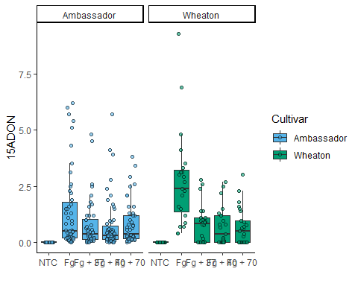 ### a. Using MassperSpeed as Y variable

Seed.mass.plot <- ggplot(Mycotoxin_Data, aes(x = Treatment, y = MassperSeed_mg, fill = Cultivar)) +  
 geom_boxplot(outliers = F) +   
 xlab("") +   
 ylab("Seed Mass (mg)") +   
 geom_point(alpha = 0.6, pch = 21, color = "black", position = position_jitterdodge()) +  
 scale_color_manual(values = c(cbbPalette[3], cbbPalette[4])) +  
 scale_fill_manual(values = c(cbbPalette[3], cbbPalette[4])) +  
 theme_classic() +  
 facet_wrap(~Cultivar)  
  
Seed.mass.plot

## Warning: Removed 2 rows containing non-finite outside the scale range  
## (`stat_boxplot()`).

## Warning: Removed 2 rows containing missing values or values outside the scale range  
## (`geom_point()`).

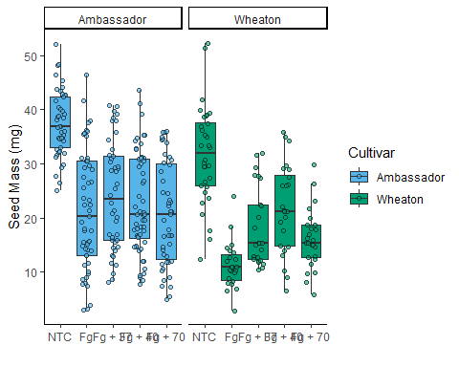

### using ggarrange

Combine.plot <- ggarrange(  
 DON.Plot,  
 X15ADON.Plot,   
 Seed.mass.plot,   
 labels = c("A", "B", "C"),  
 nrow = 1,  
 ncol = 3,  
 common.legend = TRUE,  
 legend = "bottom"  
)

## Warning: Removed 8 rows containing non-finite outside the scale range  
## (`stat_boxplot()`).

## Warning: Removed 8 rows containing missing values or values outside the scale range  
## (`geom_point()`).

## Warning: Removed 8 rows containing non-finite outside the scale range  
## (`stat_boxplot()`).

## Warning: Removed 8 rows containing missing values or values outside the scale range  
## (`geom_point()`).

## Warning: Removed 10 rows containing non-finite outside the scale range  
## (`stat_boxplot()`).

## Warning: Removed 10 rows containing missing values or values outside the scale range  
## (`geom_point()`).

## Warning: Removed 2 rows containing non-finite outside the scale range  
## (`stat_boxplot()`).

## Warning: Removed 2 rows containing missing values or values outside the scale range  
## (`geom_point()`).

Combine.plot

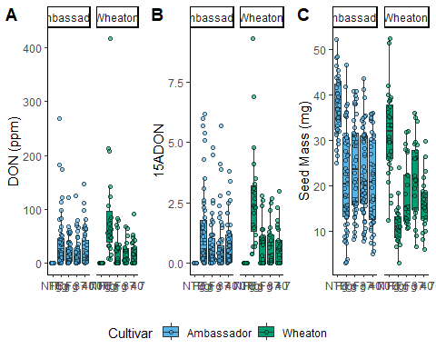

# Appling Statistics using t test

## a.

DONplot.pwc <- ggplot(Mycotoxin_Data, aes(x = Treatment, y = DON, fill = Cultivar)) +  
 geom_boxplot(outliers = F) +   
 xlab("") +   
 ylab("DON (ppm)") +   
 geom_point(alpha = 0.6, pch = 21, color = "black", position = position_jitterdodge()) +  
 scale_color_manual(values = c(cbbPalette[3], cbbPalette[4])) +  
 scale_fill_manual(values = c(cbbPalette[3], cbbPalette[4])) +  
 theme_classic() +  
 facet_wrap(~Cultivar) +  
 stat_compare_means(method = "t.test", label = "p.signif",   
 comparisons = list(c("NTC", "Fg"),   
 c("Fg", "Fg + 37"),   
 c("Fg + 37", "Fg + 40"),   
 c("Fg + 40", "Fg + 70")))  
  
DONplot.pwc

## Warning: Removed 8 rows containing non-finite outside the scale range  
## (`stat_boxplot()`).

## Warning: Removed 8 rows containing non-finite outside the scale range  
## (`stat_signif()`).

## Warning: Removed 8 rows containing missing values or values outside the scale range  
## (`geom_point()`).

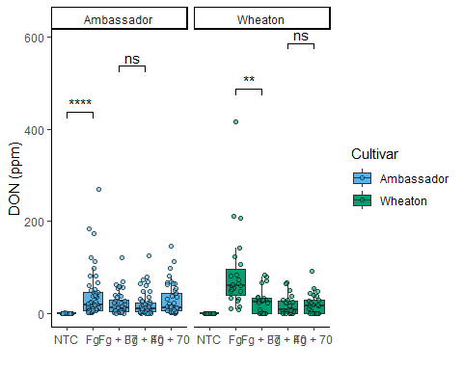

## b.

X15ADONplot.pwc <- ggplot(Mycotoxin_Data, aes(x = Treatment, y = X15ADON, fill = Cultivar)) +  
 geom_boxplot(outliers = F) +   
 xlab("") +   
 ylab("15ADON") +   
 geom_point(alpha = 0.6, pch = 21, color = "black", position = position_jitterdodge()) +  
 scale_color_manual(values = c(cbbPalette[3], cbbPalette[4])) +  
 scale_fill_manual(values = c(cbbPalette[3], cbbPalette[4])) +  
 theme_classic() +  
 facet_wrap(~Cultivar) +  
 stat_compare_means(method = "t.test", label = "p.signif",   
 comparisons = list(c("NTC", "Fg"),   
 c("Fg", "Fg + 37"),   
 c("Fg + 37", "Fg + 40"),   
 c("Fg + 40", "Fg + 70")))   
 X15ADONplot.pwc

## Warning: Removed 10 rows containing non-finite outside the scale range  
## (`stat_boxplot()`).

## Warning: Removed 10 rows containing non-finite outside the scale range  
## (`stat_signif()`).

## Warning: Removed 10 rows containing missing values or values outside the scale range  
## (`geom_point()`).

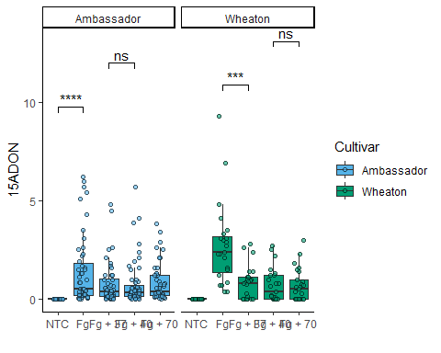

## c.

Seed.massplot.pwc <- ggplot(Mycotoxin_Data, aes(x = Treatment, y = MassperSeed_mg, fill = Cultivar)) +  
 geom_boxplot(outliers = F) +   
 xlab("") +   
 ylab("Seed Mass (mg)") +   
 geom_point(alpha = 0.6, pch = 21, color = "black", position = position_jitterdodge()) +  
 scale_color_manual(values = c(cbbPalette[3], cbbPalette[4])) +  
 scale_fill_manual(values = c(cbbPalette[3], cbbPalette[4])) +  
 theme_classic() +  
 facet_wrap(~Cultivar) +  
 stat_compare_means(method = "t.test", label = "p.signif",   
 comparisons = list(c("NTC", "Fg"),   
 c("Fg", "Fg + 37"),   
 c("Fg + 37", "Fg + 40"),   
 c("Fg + 40", "Fg + 70")))

## **Combining all plots with statistics**

Combineplot.pwc <- ggarrange( DONplot.pwc,  
 X15ADONplot.pwc,   
 Seed.massplot.pwc,   
 labels = c("A", "B", "C"),  
 nrow = 1,  
 ncol = 3,  
 common.legend = TRUE,  
 legend = "bottom")

## Warning: Removed 8 rows containing non-finite outside the scale range  
## (`stat_boxplot()`).

## Warning: Removed 8 rows containing non-finite outside the scale range  
## (`stat_signif()`).

## Warning: Removed 8 rows containing missing values or values outside the scale range  
## (`geom_point()`).

## Warning: Removed 8 rows containing non-finite outside the scale range  
## (`stat_boxplot()`).

## Warning: Removed 8 rows containing non-finite outside the scale range  
## (`stat_signif()`).

## Warning: Removed 8 rows containing missing values or values outside the scale range  
## (`geom_point()`).

## Warning: Removed 10 rows containing non-finite outside the scale range  
## (`stat_boxplot()`).

## Warning: Removed 10 rows containing non-finite outside the scale range  
## (`stat_signif()`).

## Warning: Removed 10 rows containing missing values or values outside the scale range  
## (`geom_point()`).

## Warning: Removed 2 rows containing non-finite outside the scale range  
## (`stat_boxplot()`).

## Warning: Removed 2 rows containing non-finite outside the scale range  
## (`stat_signif()`).

## Warning: Removed 2 rows containing missing values or values outside the scale range  
## (`geom_point()`).

Combineplot.pwc

